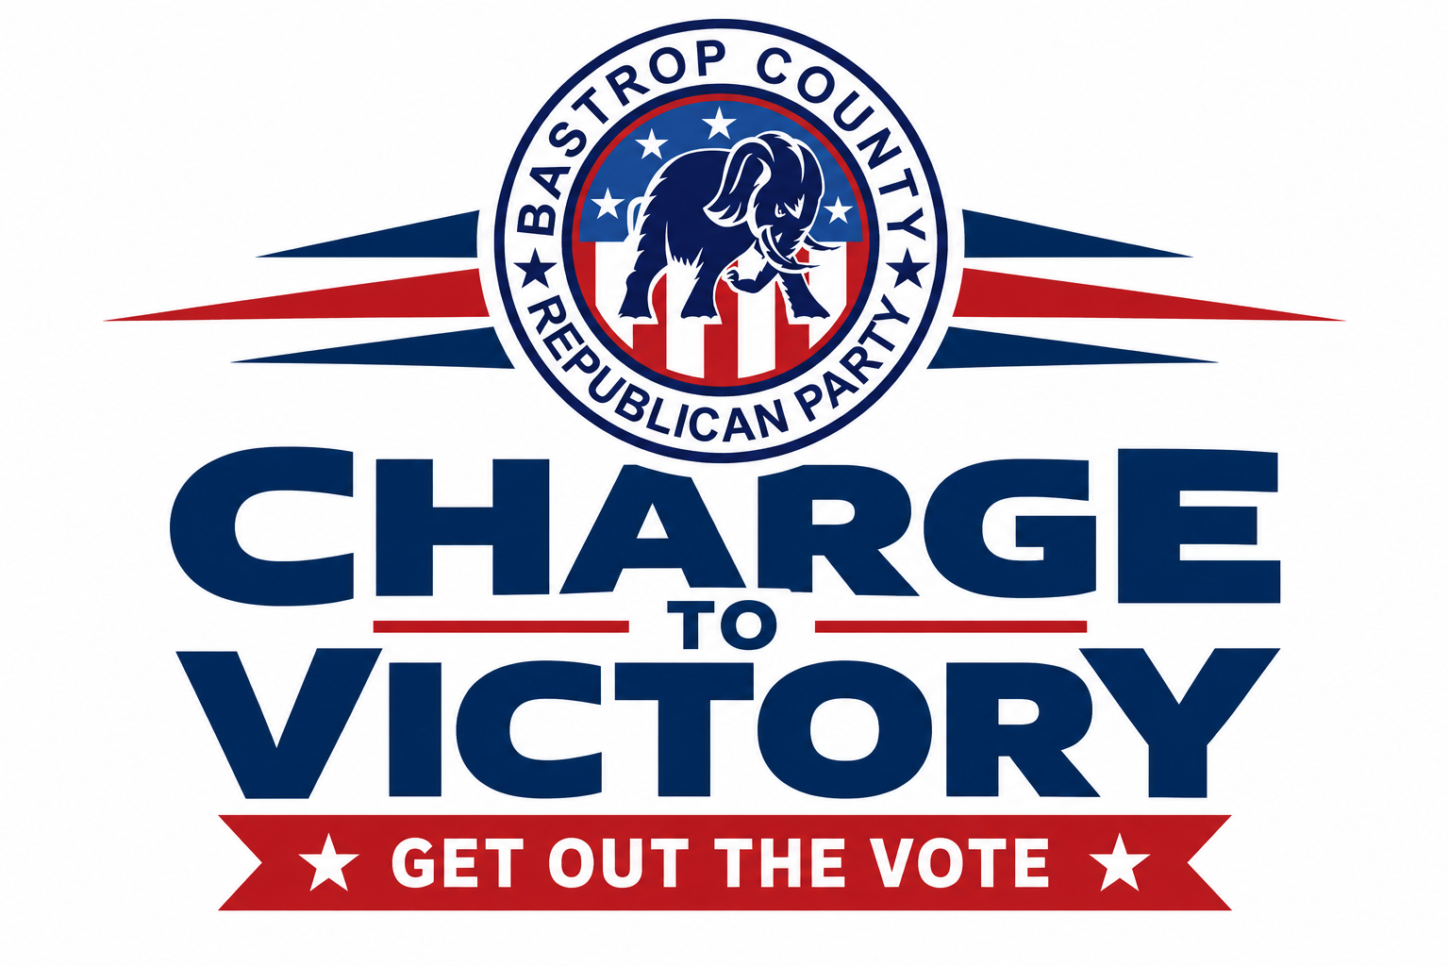
September 19 - November 3, 2026

Campaign Purpose
Our goal is to maximize Republican voter turnout across Bastrop County by creating consistent voter contact from campaign launch through Election Day. The campaign will combine direct voter outreach, community events, and full poll-location coverage with a volunteer team of 50-60 people.
Our GOTV Strategy
BLOCK WALKING (Need coordinator)  Neighborhood-based voter contact beginning September 12, with regular weekend walks and an additional push before early voting. | PHONE BANKING (Need coordinator)  Centralized calling from GOTV Bastrop headquarters beginning October 19, with an expanded final push on November 2.
POLL COVERAGE (Need coordinator)  Volunteers assigned to early voting locations and Election Day polling locations so Republican voters see an organized presence throughout voting. | CHARGE TO VICTORY-Community Events  Three major community events in Smithville, Elgin, and The Colony (Bastrop) to build energy, recruit volunteers, and drive voters toward early voting and Election Day.
Campaign Timeline & Action Plan
DATE / PERIOD | ACTIVITY | PLAN OF ACTION
Sept. 13 - Nov. 1 | Weekly GOTV Zoom | Sunday volunteer/leadership coordination meeting, 7:30-8:30 p.m., to review progress and upcoming needs. Contact Jen Bezner to sign up.
Sept. 19- Oct. 24 | Weekend Block Walks | Saturday block walks, 9:00 a.m.-12:00 p.m.; Sunday block walks, 5:00-7:00 p.m., as scheduled.
Sept. 21- Monday | GOTV Marketing Launch | Begin coordinated GOTV messaging and social media outreach; maintain planned content through mid-October. Launch after Boots & BBQ
Oct 5 -Monday | Last day to register to vote
Oct. 10-Saturday | Charge to Victory - Smithville | 4:00-7:00 p.m. at Smithville VFW, 557 NW Loop 230.
Oct. 11-Sunday | Charge to Victory - Elgin | 1:00-3:00 p.m. VFW 118 Old Sayers Rd, Elgin
Oct. 11-Sunday | Charge to Victory - The Colony (Bastrop) | 5:00-7:00 p.m. The Colony Multipurpose Room, Stephen F. Austin Blvd.
Oct. 12-16 (Mon-Fri) | Weekday Block-Walk Push | Block walking Monday-Friday, 5:00-7:00 p.m., to build momentum immediately before early voting.

EARLY VOTING & ELECTION DAY EXECUTION
DATE / PERIOD | ACTIVITY | PLAN OF ACTION
Oct. 19-Monday | Early Voting Begins
Oct. 19-23 (Monday-Friday) | Early Voting Week 1 | Staff early-voting locations in scheduled shifts throughout the day. Voting is from 8am-5 pm. Phone bank from GOTV headquarters, 5:00-7:00 p.m.
Oct. 24-25 (Sat & Sun) | Early Voting Weekend | Maintain weekend poll coverage in scheduled shifts (Sat 7am-7pm, Sun 9am-3pm)
Oct. 26-30 (Monday-Friday) | Early Voting Final Week | Continue full poll coverage and daily phone banking. Polls are open 7am-7pm, and Phone bank each night at Bastrop Headquarters from 5-7pm
Nov. 2 (Monday) | Final Phone-Bank Push | Extended phone bank at GOTV headquarters, 2:00-8:00 p.m.
Nov. 3 (Tuesday) | Election Day | Cover all 15-polling locations in four shifts: 7-10 a.m., 10 a.m.-1 p.m., 1-4 p.m., and 4-7 p.m.

Volunteer Goal: 50-75 People
Sign up here to volunteer: https://www.signupgenius.com/go/20F0D4FA8A82DA7FFC70-65518372-gotv

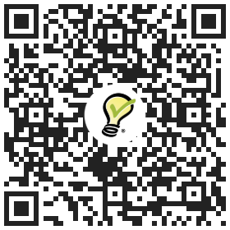

• Block walkers
• Phone-bank/text callers at Headquarters
• Early voting poll volunteers at EV sites
• Election Day poll volunteers at all locations

Contact information:
Jen Bezner
Jenbezner@gmail.com
512-680-4665

